# Графік виборів

[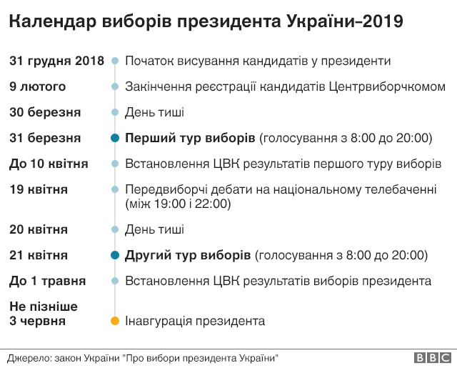](http://orda.gov.ua/wp-content/uploads/2019/03/%D0%B3%D1%80%D0%B0%D1%84%D1%96%D0%BA-%D0%B2%D0%B8%D0%B1%D0%BE%D1%80%D1%96%D0%B2.png)

# Вибори без порушень

[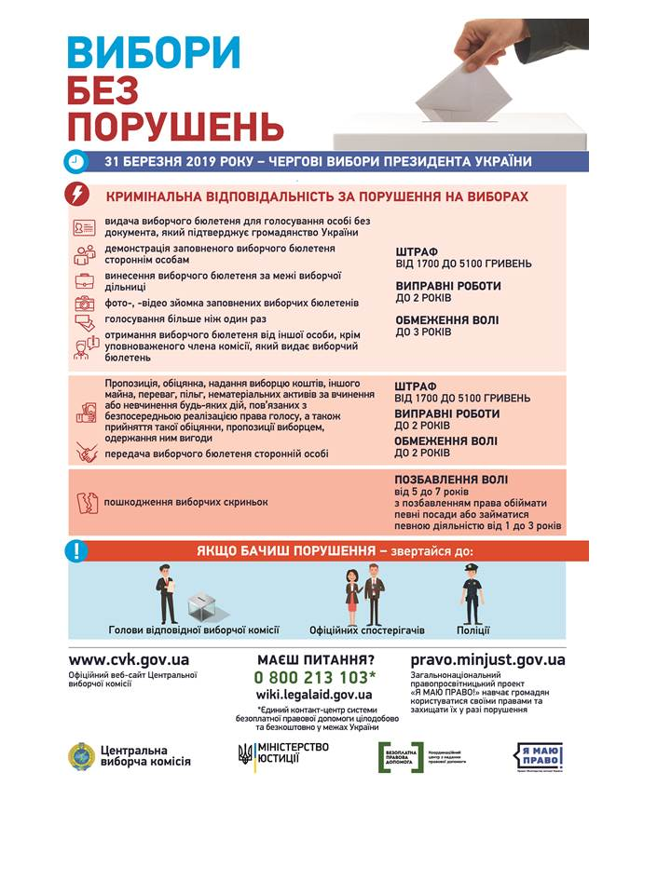](http://orda.gov.ua/wp-content/uploads/2019/03/%D0%B2%D0%B8%D0%B1%D0%BE%D1%80%D0%B8-%D0%B1%D0%B5%D0%B7-%D0%BF%D0%BE%D1%80%D1%83%D1%88%D0%B5%D0%BD%D1%8C.jpg)

# Пам’ятка виборця

[](http://orda.gov.ua/wp-content/uploads/2019/03/%D0%BF%D0%B0%D0%BC%D1%8F%D1%82%D0%BA%D0%B0-%D0%B2%D0%B8%D0%B1%D0%BE%D1%80%D1%86%D1%8F-1.jpg)

[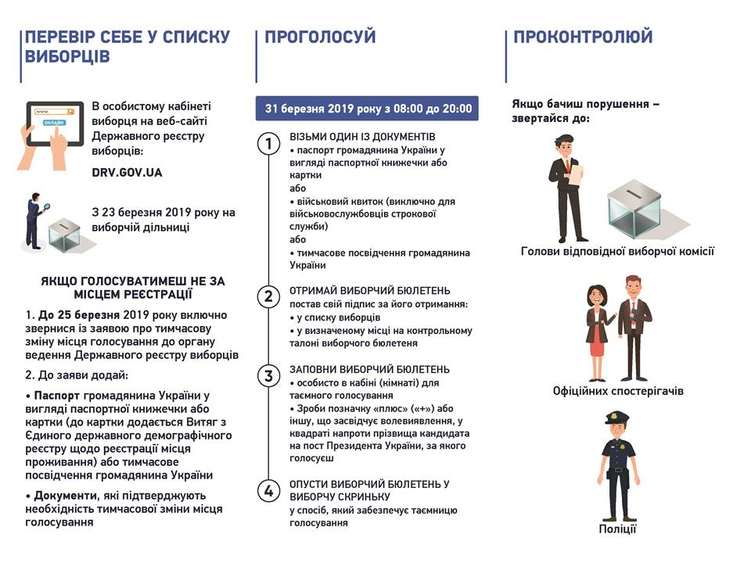](http://orda.gov.ua/wp-content/uploads/2019/03/%D0%BF%D0%B0%D0%BC%D1%8F%D1%82%D0%BA%D0%B0-%D0%B2%D0%B8%D0%B1%D0%BE%D1%80%D1%86%D1%8F-2.jpg)

[](http://orda.gov.ua/wp-content/uploads/2019/03/%D0%B2%D0%B8%D0%B1%D0%BE%D1%80%D0%B8-%D0%B1%D0%B5%D0%B7-%D0%BF%D0%BE%D1%80%D1%83%D1%88%D0%B5%D0%BD%D1%8C-1.jpg)

[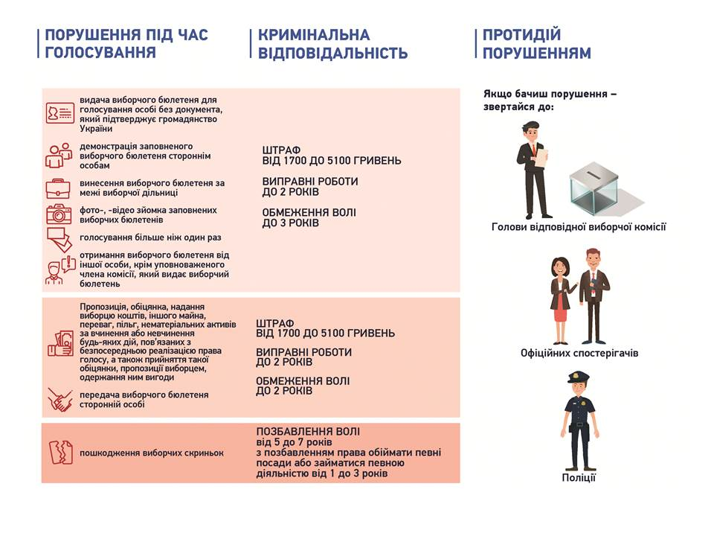](http://orda.gov.ua/wp-content/uploads/2019/03/%D0%B2%D0%B8%D0%B1%D0%BE%D1%80%D0%B8-%D0%B1%D0%B5%D0%B7-%D0%BF%D0%BE%D1%80%D1%83%D1%88%D0%B5%D0%BD%D1%8C-2.jpg)

# Дорожня карта виборця<http://orda.gov.ua/wp-content/uploads/2019/03/%D0%B4%D0%BE%D1%80%D0%BE%D0%B6%D0%BD%D1%8F-%D0%BA%D0%B0%D1%80%D1%82%D0%B0-%D0%B2%D0%B8%D0%B1%D0%BE%D1%80%D1%86%D1%8F.jpg>

**Як змінити місце голосування?**

[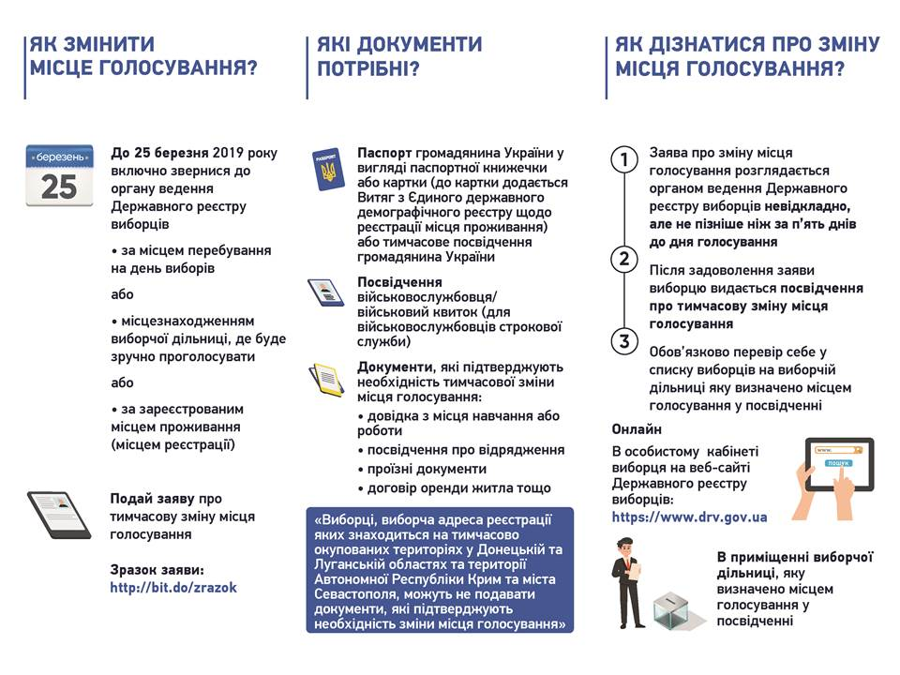](http://orda.gov.ua/wp-content/uploads/2019/03/%D1%8F%D0%BA-%D0%B7%D0%BC%D1%96%D0%BD%D0%B8%D1%82%D0%B8-%D0%BC%D1%96%D1%81%D1%86%D0%B5-%D0%B3%D0%BE%D0%BB%D0%BE%D1%81%D1%83%D0%B2%D0%B0%D0%BD%D0%BD%D1%8F-2.jpg)

**Як переселнцю проголосувати на виборах Президента?**[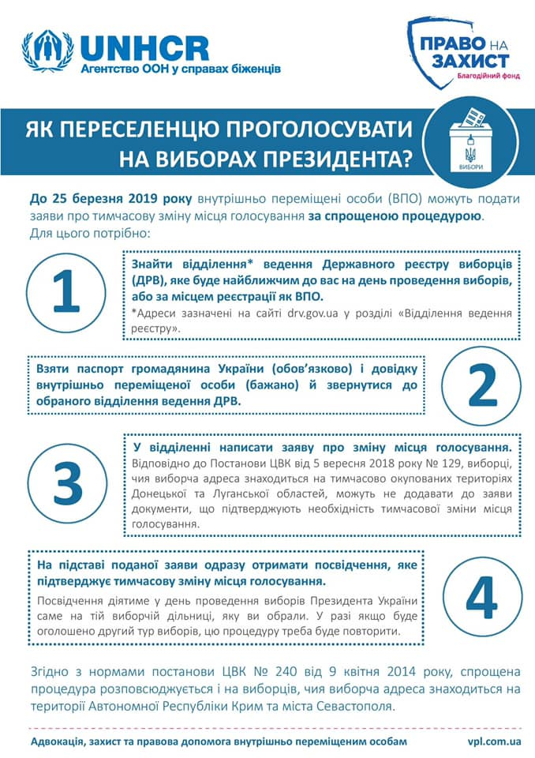](http://orda.gov.ua/wp-content/uploads/2019/03/Golos-peresel.jpg)